
APPLICATION FORM
PROTOTYPE DEVELOPMENT RESEARCH GRANT SCHEME (PRGS)
Skim Geran Penyelidikan Pembangunan Prototaip

JABATAN PENDIIDIKAN TINGGI
KEMENTERIAN PENDIDIKAN TINGGI
MINISTRY OF HIGHER EDUCATION

A. Application Details
A(i). Selected Grant Scheme | PRGS 2025
A(ii). Title of Proposed Research Project
An Intelligent Apps for Risk-Aware Decision Making and Spatial Navigation in Confined Environment.
A(iii). Keywords
spatial navigation, risk-aware decision making, smart space planning, reinforced learning

B. Details of Project Leader
B(i). Name | Izwan Nizal Mohd Shaharanee
B(ii). Academic Qualification | PhD  Sarjana Sains (Komputer Sains)  Ijazah Sarjana Muda Teknologi Maklumat (Kepujian)
B(iii). Nationality | Malaysia
B(iv). IC/Passport No. | 790427086245
B(v). Position | Associate Professor
B(vi). Institution | Universiti Utara Malaysia (UUM)
B(vii). Faculty/Centre | Pusat Pengajian Sains Kuantitatif, Decision Science
B(viii). Unit/Department | Decision Science
B(ix). Office Phone No. | 6049286364
B(x). Handphone No. | 60125354691
B(xi). E-mail Address | nizal@uum.edu.my
B(xii). Date of First Appointment with this Institution | 04/08/2002
B(xiii). Type of Service (Permanent/Contract)/Last Date of Contract | Permanent 27/04/2039

C. Research Information
C(i). Research Domain
Research Domain | Sub Research Domain
Information and Communication Technology | Artificial Intelligence

C(ii). Research Cluster
Cluster: Frontier Technologies & Advanced Manufacturing
C(iii). 17 ‘Big Bolds’ in Ekonomi MADANI
Digital- and Technology-based HGHV Industries
This research aligns with Big Bold No. 11 of Ekonomi MADANI, which focuses on Digital and Technology-Based High Growth High Value (HGHV) Industries. The development of an intelligent prototype for risk-aware decision-making and spatial navigation using reinforcement learning directly supports Malaysia’s vision for AI-driven innovation, industrial automation, and digital transformation. The project will enhance Malaysia’s competitive edge in AI, facilitate safer and more efficient navigation in confined environments, and contribute to the nation’s digital economy by fostering high-value AI applications in various industries.
C(iv). 10-10 Malaysia Science, Technology, Innovation and Economy (MySTIE) - based on 10 Socio-Economic Drivers
MySTIE:
(a) 10 Socio-Economic Drivers: Business and Financial Services
(b) 10 Science and Technology Drivers: Advanced Intelligent Systems
This research aligns with the 10-10 MySTIE Framework under the Business and Financial Services socio-economic driver and the Advanced Intelligent Systems technology driver. The project aims to develop an AI-powered intelligent prototype for risk-aware decision-making and spatial navigation in confined environments, leveraging Reinforcement Learning. This innovation contributes to the business and financial sector by improving risk assessment, operational safety, and automated navigation in complex business environments. Additionally, the research supports Malaysia’s digital transformation by advancing AI-driven intelligent systems that optimize decision-making, automation, and financial analytics. The outcomes of this research will benefit industries that rely on AI-based risk prediction and autonomous systems, aligning with Malaysia’s goal of fostering high-value, knowledge-driven economic
growth.
C(v). Sustainable Development Goals (SDGs)
SDG: SDG 9 – Industry, Innovation and Infrastructure
This research aligns with SDG 9: Industry, Innovation, and Infrastructure by developing an AI-powered intelligent prototype that enhances risk-aware decision-making and spatial navigation in confined environments. The project contributes to industrial innovation by integrating Reinforcement Learning to improve decision support systems, operational efficiency, and risk mitigation in business and financial services. Additionally, the research fosters technological advancements in Industry 4.0, supporting Malaysia’s transition toward a high-value, AI-driven economy. By promoting the adoption of AI in business infrastructure, this research strengthens industrial resilience, sustainability, and digital transformation, ensuring a smarter and more innovative industrial landscape.
C(vi). Research Related Ministries (including agencies thereof)
Ministry:
Kementerian Perumahan dan Kerajaan Tempatan (Ministry of Housing and Local Government)
This research aligns with the Ministry of Housing and Local Government (KPKT) by developing an AI-powered intelligent prototype for risk-aware decision-making and spatial navigation in confined environments. The project contributes to smart city initiatives, urban planning, and public safety by integrating AI into municipal decision-making processes. The prototype enhances local government capabilities in managing confined spaces, optimizing navigation for public safety, and improving risk management in high-density urban areas. Additionally, this research supports sustainable housing and smart city development by providing AI-driven solutions for optimizing infrastructure planning, building safety, and local governance decision-making.
C(vii). This prototype development research proposal is a continuation from a previous grant(s)
 | Fundamental Research Grants Scheme (FRGS)
 | Percentage of Contribution to This Research (%) | 100%
 | Project Title | An Improved Framework of Tree-structured Data Mining for Business Process Logs Analysis
 | Project Reference no. | FRGS/1/2018/ICT02/UUM/02/5
 | Duration and Year Approved | 01/01/2019 - 31/12/2020
 | Amount Approved (RM) | 67200
 | Final Report (please attach) | Refer Attachment

 | Other Research Grants:
 | Percentage of Contribution to This Research (%)
 | Project Title
 | Project Reference no.
 | Duration and Year Approved
 | Amount Approved (RM)
 | Final Report (please attach)
 | RMC Verification Letter (please attach)
 | Project Leader of this Grants | (Yes/No (if no, please attach approval letter from the Project Leader)

C(viii). Location of Research
C(ix). Duration of this research
From | 1/December/2025
To | 30/November/2027
Duration | 2 years

C(x). Other Researchers
Name | IC/Passport Number | Faculty/School/Centre/Unit/De | Position | Area of Expertise | Role
Jastini Mohd Jamil | 7906110  25290 | Universiti  Utara  Malaysia | Senior  Lecturer  (Senior  Lecturer) | Data Analytics, Data Mining | Implementing data mining techniques to extract insights from spatial and risk-related data
Dr. Mohamad Naim Abd. Halim | 7701220  25515 | Universiti  Utara  Malaysia | Senior  Lecturer  (Senior  Lecturer) | Market Validation Lead, Business Focus | Assist in planning using tools like the Business Model Canvas (BMC) and market sizing (TAM-SAM-SOM) and help connect with potential industry partners.

C(xi). Research projects that have been completed or are on-going by researchers related to this proposed prototype development project.
Title | Grant Name | Role | Progress (%) | Status | Duration | Start Date | End Date
A New Model of Network Streaming Data to Classify  High Risk Objects for Cyber Threat Intelligence | FRGS  2021-1 | Member | 82.57 | In Progress | 3 years | 7/9/2021 | 6/9/2021
An Improved Framework of Tree-structured Data  Mining for Business Process Logs Analysis | FRGS  2018-1 | Project  Leader | 100 | Complete  - KPI Not  Achieved | 2 years 9 months | 1/1/2019 | 30/9/2021
A New Method for Mining Subtree On Structure–  Preserving Flat Data for Tree Structured Data | FRGS  2013-2 | Project  Leader | 100 | Complete  - KPI  Achieved | 2 years | 1/12/2013 | 30/11/2015
EARLY WARNING DENGUE TRANSMISSION  CONTROL MODELS WITH A HYBRID OF  STOCHASTIC FRONTIER ANALYSIS AND  SYSTEM DYNAMICS | FRGS  2013-2 | Member | 100 | Complete  - KPI  Achieved | 2 years | 1/12/2013 | 30/11/2015
DEVELOPMENT OF TASK MANAGER ANALYTICS  : AN ENHANCEMENT OF TASK MANAGER | RECGS | Member | 100 | In Progress | 1 year | 15/3/2018 | 14/3/2019
Optimizing Association Rule: Handling Missing  Values and Refining the Statistical Analysis | RAGS | Member | 100 | Complete  - KPI  Achieved | 3 years 1 month | 29/1/2013 | 3/2/2016
Prototaip Sub-Sistem Asis : Pengurusan Markah  Efektif | RAGS | Project  Leader | 100 | Complete  - KPI  Achieved | 2 years | 15/12/2012 | 14/12/2014
Interestingness and Quality of association Rules  Derived from Relational Data | Others | Project  Leader | 100 | Complete  - KPI  Achieved | 11  months | 29/07/2012 | 29/06/20130

C(xii). Please furnish information on academic publications and intellectual properties by the team members.
A. List of publications for the last five (5) years

Title | Name of Journal | Year
Machine Learning Methods Based on Storm Surge Disaster Loss in  Computing Applications | International Journal of Intelligent Systems and  Applications in Engineering | 2023
Enabling efficient business process mining using flatten sequential structure model | Indonesian Journal of Electrical Engineering and Computer Science | 2023
Clustering student performance data using k-means algorithms | Journal of Computational Innovation and Analytics  (JCIA) | 2023
Enabling efficient business process mining using flatten sequential structure model | Indonesian Journal of Electrical Engineering and Computer Science | 2023
Framework to Mine XML Format Event Logs | International Journal of Advances in Soft Computing and Its Application | 2022
Papan Pemuka (Dashboard) Sebagai Alternatif Visualisasi Integriti Staf | International Journal of Law, Government and  Communication | 2022
Predicting Student Performance Using Data Mining Approach: A Case Study in Oman | Mathematical Statistician and Engineering Applications | 2022
Determinants of students not paying their academic fees debts | Proceedings of the 8th Annual ECOFI Symposium  2022 | 2022
A DECISION TREE CLASSIFIER FOR PREDICTING VOTER TURNOUT IN MALAYSIAN GENERAL ELECTION | CENTRAL ASIA AND THE CAUCASUS | 2021
KEBERKESANAN PENERAPAN KEMAHIRAN INSANIAH MELALUI AKTIVITI KOKURIKULUM BERKREDIT DI KALANGAN MAHASISWA | International Journal of Education, Psychology and  Counselling | 2021
Perceived Usefulness of Instagram as a Marketing Tool in Higher Education Institutions: Persepsi Kegunaan Instagram Sebagai Alat Pemasaran di Institusi Pengajian Tinggi | Journal of Information and Communication  Technology in Education | 2021
A Framework to Analyze Business Process Log in XML Format | Turkish Journal of Computer and Mathematics  Education (TURCOMAT) | 2021
Prediction of Student Dropout in Malaysian’s Private Higher Education Institute using Data Mining Application | Turkish Journal of Computer and Mathematics  Education (TURCOMAT) | 2021
Variations in the number of hidden nodes through multilayer perceptron networks to predict cycle time | Journal of Information and Communication  Technology | 2021
Framework to Reduce Cost Scrapping and Cost of Assemble Test Capacity in Semiconductor Integrated Circuit Manufacturing | Technology Reports of Kansai University (ISSN:  04532198) | 2020
Effect of Small Private Online Course (SPOC) on Students' Achievement in Pre-University Chemistry | International Journal of Learning, Teaching and  Educational Research | 2020
Assessing Lecturer’s Readiness for Online Learning Implementation during COVID -19 Outbreak | Ilkogretim Online-Elementary Education Online | 2020
Identify Entrepreneurial Opportunity by Mining Data from Social Media | International Journal of Advanced Science and  Technology | 2020

B. List of Intellectual Properties (IPs)

Patent Number | Patent Type | Issue Date | Description
TS2024074 | Trade Secret | 06/04/2024 | The Attribute-Focused Structured Data Reintegration Technique (AFSDRT) represents an innovative approach to reorganizing flattened data into its original structured, hierarchical format. This technique emerges from the need to restore detailed structural and relational contexts to data previously simplified for analytical processing. AFSDRT methodically employs unique attribute names as a key to reconstruct the complex structured form of data, ensuring the preservation of contextual integrity and relational significance across transactions. This process enables a refined transformation of data from a flat representation back to its structured counterpart, enhancing usability for further analysis and application. Ideal for complex data management, research databases, and business intelligence frameworks, AFSDRT uniquely facilitates the balance between analytical simplicity and the necessity for maintaining comprehensive data detail, offering a solution that supports detailed insights. The primary function of the Attribute-Focused Structured Data Reintegration Technique (AFSDRT) is to transform data from a flattened format back into its original structured, hierarchical form, ensuring the retention of important relational and contextual details. This reintegration process is guided by the identification and organization of unique data attributes, which are crucial for preserving the integrity of the data's original structure. The objectives of AFSDRT include: 1. Data Structure Restoration: To reinstate the hierarchical organization of data that was previously flattened for analysis, thereby allowing for the return to its complex structured format. 2. Contextual Integrity Maintenance: To ensure that the relational context and integrity of the data are preserved during the reintegration process, facilitating a more accurate and meaningful analysis. 3. Enhanced Data Usability: To improve the usability of data for further processing and analysis by restoring its structure. The Attribute-Focused Structured Data Reintegration Technique (AFSDRT) is an original invention that was conceived to address the specific challenge of restoring the structural and hierarchical integrity of data after it has been flattened for analytical purposes. This technique is the result of a novel approach to data reintegration, focusing on the use of unique attributes to guide the reconstruction process. Unlike existing methods that may prioritize either the flattening or analysis of data without considering the subsequent restoration of its original form, AFSDRT offers a unique solution that seamlessly bridges the gap between data simplification and the need for detailed structural complexity. The development of AFSDRT involved a creative synthesis of concepts from data structure theory, database management, and information retrieval, leading to an innovative method that enhances both the utility and analysis of structured data. The technique's originality lies in its specific. The Attribute-Focused Structured Data Reintegration Technique (AFSDRT) involves a structured process designed for the efficient reorganization of flattened data back into its original hierarchical format. This process is divided into key components or phases that ensure the comprehensive and accurate reintegration of data: 1. Attribute Identification: The first component involves identifying and filtering unique attribute names from the flattened data. This step is crucial for establishing the framework within which the data will be restructured. 2. Structured Table Creation: Utilizing the identified attributes, a structured table is created. This table serves as the foundation for reassembling the data, with columns corresponding to the unique attributes identified in the first phase. 3. Data Reintegration: In this phase, the flattened data is methodically reintegrated into the structured table. This involves parsing each transaction from the flattened dataset and placing dat. The Attribute-Focused Structured Data Reintegration Technique (AFSDRT) offers significant benefits across various sectors by enhancing the ability to manage, analyze, and utilize complex data structures efficiently. Nation: On a national level, government agencies responsible for large-scale data management, such as census data, environmental monitoring, and healthcare information, can benefit from AFSDRT by improving the accuracy and efficiency of data analysis, leading to more informed policymaking and public services. Institutions: Academic and research institutions stand to gain through enhanced capabilities for conducting complex data analyses, fostering innovation in scientific research, and enabling a deeper understanding of vast datasets across disciplines such as biology, sociology, and economics. Community: Community organizations and NGOs can leverage AFSDRT to better organize and analyze data related to community needs assessments, resource distribution, and impact. The Attribute-Focused Structured Data Reintegration Technique (AFSDRT) stands out for its unique approach to data reintegration, particularly in how it handles the restoration of flattened data to its original structured format. Unlike conventional methods, which may either flatten data for analysis or structure data for storage with no efficient mechanism to transition between these states, AFSDRT specifically targets the challenge of reassembling data into its hierarchical form post-analysis. This is accomplished by leveraging unique attribute names as a key mechanism for the reorganization process, a feature not commonly emphasized in existing techniques. Furthermore, AFSDRT distinguishes itself by ensuring that the integrity and contextual richness of the original data are meticulously preserved during reintegration.
TS2024073 | Trade Secret | 06/04/2024 | The Business Process Log Data Mining Enhancement Framework (BPDM-EF) is a comprehensive solution designed to optimize the extraction, processing, and analysis of business process log data, particularly those in XML format. This framework addresses the challenge of dealing with raw, semi-structured business log data that is often cluttered with irrelevant information or corrupted elements. BPDM-EF introduces a systematic preprocessing phase that filters non-transactional data and repairs or removes corrupted data elements, ensuring that only relevant, clean data is forwarded for analysis. Following preprocessing, the framework employs the Flatten Sequential Structure Model (FSSM) to convert the cleaned XML data into a structured format. This structured data is then primed for efficient and effective mining, allowing for the extraction of valuable insights into business processes. By streamlining the transformation of complex XML logs into an analyzable format, BPDM-EF significantly. The Business Process Log Data Mining Enhancement Framework (BPDM-EF) aims to refine the handling and analysis of XML-formatted business process logs through a series of targeted functions and objectives: 1. Preprocessing and Cleansing: To systematically filter and clean raw business process log data, removing irrelevant and corrupted data elements, thereby ensuring that only pertinent data is subject to analysis. 2. Structured Data Conversion: Utilizing the Flatten Sequential Structure Model (FSSM), BPDM-EF transforms semi-structured XML data into a structured format conducive to detailed analysis and mining, enhancing the accuracy and efficiency of data processing. 3. Enhancement of Data Mining Capabilities: By providing a cleaner, structured dataset, BPDM-EF enables more sophisticated mining techniques to uncover insights into business operations, process efficiency, and potential areas for improvement. 4. Operational Efficiency and Decision Support: The ultimate objective. The Business Process Log Data Mining Enhancement Framework (BPDM-EF) stands as an original invention, developed from the ground up to address specific challenges associated with the analysis of XML-formatted business process logs. Its innovative approach lies in the systematic preprocessing, cleansing, and structured conversion of complex, semi-structured data a methodology not found in existing frameworks. By integrating the unique Flatten Sequential Structure Model (FSSM) for data conversion, BPDM-EF introduces a novel technique to streamline the transformation of XML data into an analyzable format, significantly enhancing data mining capabilities. This invention is the result of extensive research and experimentation, aimed at overcoming the limitations of current data processing methods, particularly in handling the intricacies of business process logs.  The Business Process Log Data Mining Enhancement Framework (BPDM-EF) encompasses a series of components and phases tailored to optimize the analysis of business process logs: 1. Preprocessing Phase: This initial component involves the cleansing and filtering of raw XML business process log data. It targets the removal of irrelevant information and corrupted data elements, ensuring that the dataset moving forward is both clean and relevant.2. Structured Data Conversion: Leveraging the Flatten Sequential Structure Model (FSSM), this phase converts the preprocessed, semi-structured XML data into a structured format. This transformation is crucial for facilitating deeper and more efficient data analysis. 3. Data Mining Enhancement With clean, structured data, BPDM-EF enhances the data mining process by allowing for more sophisticated analyses. This component is designed to extract actionable insights from the structured data, aiding in the identification of operation. The Business Process Log Data Mining Enhancement Framework (BPDM-EF) offers substantial benefits and contributions across various sectors, enhancing the capacity for data-driven decision-making and operational efficiency. Nation: At the national level, governmental bodies can utilize BPDM-EF to improve public service delivery through the optimized analysis of process logs, thereby enhancing efficiency, transparency, and responsiveness to citizen needs. Institutions: Corporations and businesses stand to gain significantly, as BPDM-EF enables a more effective understanding of operational workflows, identifying bottlenecks and areas for improvement. This leads to streamlined operations, cost savings, and enhanced competitive advantage. Community: Nonprofit organizations and community groups can leverage BPDM-EF to analyze data related to service delivery processes, optimizing their operations to better meet community needs and maximize the impact of their programs. Potential. The Business Process Log Data Mining Enhancement Framework (BPDM-EF) distinguishes itself from existing methodologies through its targeted approach to processing XML-formatted business process logs. Unlike general data processing frameworks, BPDM-EF specifically addresses the unique challenges of business process log data, such as high variability, semi-structured formats, and the presence of non-transactional or corrupted data elements. Its integration of a systematic preprocessing phase to cleanse and filter data sets it apart, ensuring that only relevant data is advanced for analysis. Additionally, the use of the Flatten Sequential Structure Model (FSSM) for the conversion of semi-structured data into a structured format is a unique aspect of BPDM-EF, tailored to enhance the mining and analysis of business process logs. This specificity in design and application provides a level of precision and efficiency in data processing that is not typically found in broader data analysis tools.

D(i). Executive Summary of Research Proposal
Please state the current scenario, problem with current scenario, solution, working principles behind solution and advantage of solution compared to competition.

Managing human movement and mobility behaviour in confined spaces such as event venues, transportation hubs, and religious gatherings and many more ‘get-together’ events pose critical operational challenges. Current practices typically rely on static layouts, manual monitoring by authority with limited numbers of workers, and delayed response mechanisms, which are insufficient during high-density situations. This often leads to congestion, delayed evacuations, safety hazards, and even fatalities. A notable example is the 2015 Mina stampede during the Hajj pilgrimage, where inadequate crowd control contributed to a catastrophic loss of life, as well as the 2022 Itaewon Halloween incident in South Korea. Such tragedies underscore the urgent need for intelligent, real-time spatial management tools. Potential users, including event organizers, emergency response teams, and facility managers, face the pain of unpredictable crowd behaviour, limited visibility, and reactive (not proactive) crowd management, which compromises safety and operational efficiency. Traditional CCTV-based solutions also raise privacy concerns and lack predictive modeling and interactive optimization features. To address these issues, this project proposes the development of SDSOS (Spatial Dynamics Simulation and Optimization System), a real-time simulation tool that allows users to dynamically test and refine spatial layouts. Coupled with ASNA (Adaptive Spatial Navigation Algorithm) powered by reinforcement learning and LiDAR sensing, the system will monitor and forecast crowd movement, identify risks, and guide adaptive navigation strategies. The innovation lies in its dual capabilities: simulating layout changes, such as temporary blockades, and forecasting individual and group movement trajectories based on learned behavioral patterns. This research aligns with smart safety strategies by shifting from static monitoring approaches to data-driven, adaptive spatial planning. The proposed prototype introduces a scalable and privacy-preserving solution for enhancing crowd safety and enabling real-time spatial optimization. In doing so, it directly supports national priorities on urban safety, resilience, and AI-driven innovation.
D(ii). Detail Planning
(a) Detailed proposal of research project:
1. Research background including summary of previous research related to prototype development.

Managing human traffic dynamics in confined spaces is crucial for optimizing pedestrian movement efficiency, safety, and space utilization in environments such as airports, shopping malls, train stations, and event venues (Dhanaraj et al., 2024). Felemban et al. (2020) note that traditional crowd management methods rely on historical data, static models, and manual observation, which fail to capture real-time variations and dynamic pedestrian behaviors. With advancements in Artificial Intelligence (AI) and sensor-based tracking, LiDAR (Light Detection and Ranging) technology has emerged as a highly effective solution for real-time, high-resolution, privacy-preserving pedestrian tracking (Wang et al., 2022). Unlike conventional CCTV systems, LiDAR-based AI models enable the detection of density fluctuations, movement bottlenecks, and congestion risks dynamically (Gómez et al., 2023). However, despite its potential, existing research has not fully integrated LiDAR-based real-time pedestrian tracking with AI-driven predictive modeling for movement forecasting (Mekala et al., 2022). To address this gap, this research proposes the development of an AI-powered movement forecasting algorithm that utilizes real-time LiDAR data to predict traffic density trends and optimize spatial configurations dynamically. Additionally, this study aims to create a virtual occlusion manipulation interface, allowing users to simulate different spatial configurations, introduce or remove obstacles, and assess movement efficiency in various real-time scenarios. This integrated system will enhance space management, pedestrian flow control, and real-time decision-making in high density environments, contributing to smarter, safer, and more adaptive urban infrastructures.
2. Problem Statement

Managing human traffic flow in confined spaces is a complex challenge that requires real-time adaptability, accurate forecasting, and interactive spatial optimization (Parfyonenko, 2023). As urbanization accelerates, high-density environments such as airports, train stations, shopping malls, stadiums, and event venues continue to experience increased pedestrian congestion, making efficient movement management crucial for safety, space optimization, and emergency planning (Fu et al., 2019). Traditional pedestrian traffic monitoring relies heavily on static agent-based models, CCTV surveillance, and pre-recorded datasets, which lack the ability to dynamically adjust to real-time behavioral changes (Jain et al., 2019). Gong et al., (2023) emphasize that conventional systems fail to capture live pedestrian decision-making, occlusion effects, and dynamic space utilization trends, leading to inefficient congestion control, reduced safety measures, and suboptimal urban planning.

Mekala et al. (2022) identify that a critical limitation of existing crowd management solutions is the lack of real-time predictive analytics integrated with interactive spatial simulation. Current AI-driven models focus on static movement prediction rather than adaptive forecasting that allows users to interactively manipulate space constraints, introduce barriers, and test different spatial layouts dynamically (Oliveira, 2024). Furthermore, while LiDAR technology has proven highly effective in autonomous navigation and environmental mapping, its application in human movement prediction and real-time spatial analytics remains underdeveloped (Gómez et al., 2023). Existing AI-powered pedestrian analytics tools primarily rely on CCTV-based tracking, which poses significant privacy concerns due to the use of facial recognition and video-based monitoring (Gong et al., 2023). In contrast, LiDAR-based AI tracking provides privacy-compliant, high-precision, real-time movement analytics, but there is currently no solution that integrates LiDAR with AI-driven traffic density forecasting and interactive spatial manipulation (Gómez et al., 2023).

Another fundamental gap in existing research is the lack of AI-powered occlusion-aware navigation models for real-time pedestrian flow optimization (Nishinari et al., 2024). Most current crowd simulation tools operate on predefined movement rules, failing to account for dynamic spatial changes such as temporary obstacles, emergency evacuations, or unpredictable congestion patterns (Alazbah et al., 2025). Peri et al. (2022) argue that, without an intelligent spatial manipulation interface, urban planners, security teams, and public transport authorities are unable to test different space layouts in real time, making it difficult to optimize pedestrian flow efficiency dynamically. Emergency evacuations, for example, require adaptive models that can adjust dynamically to sudden crowd shifts, which current systems fail to provide(Alazbah et al., 2025).

To address these critical challenges, this research proposes the development of an AI-powered movement forecasting algorithm that utilizes real-time LiDAR tracking, deep learning-based traffic density prediction, and an interactive spatial occlusion simulation tool. This integrated system will enable real-time movement forecasting, intelligent space management, and AI-assisted spatial optimization, offering a transformative approach to pedestrian movement analysis and urban space design. By combining AI-powered behavioural modeling with LiDAR-based tracking and interactive spatial control, this research will contribute to safer, smarter, and more adaptive human mobility management solutions, benefiting industries such as public transportation, event security, commercial real estate, and emergency response planning.

This study not only fills the existing research gap in real-time pedestrian flow prediction and spatial manipulation but also aligns with global smart city development trends by introducing next-generation AI solutions for dynamic space management and movement efficiency optimization.

References:
Alazbah, A. A., Rabie, O., & Al-Barakati, A. (2025). Crowd Evacuation in Stadiums Using Fire Alarm Prediction. Sensors, 25(9). https://doi.org/10.3390/s25092810
Dhanaraj, R. K., Kamila, N. K., Pani, S. K., Balusamy, B., & Rajasekar, V. (2024). Artificial Intelligence For Future Intelligent Transportation: Smarter and Greener Infrastructure Design. In Artificial Intelligence for Future Intelligent Transportation: Smarter and Greener Infrastructure Design. https://doi.org/10.1201/9781003408468
Felemban, E. A., Rehman, F. U., Biabani, S. A. A., Ahmad, A., Naseer, A., Majid, A. R. M. A., Hussain, O. K., Qamar, A. M., Falemban, R., & Zanjir, F. (2020). Digital Revolution for Hajj Crowd Management: A Technology Survey. IEEE Access, 8. https://doi.org/10.1109/ACCESS.2020.3037396
Fu, Y., Shi, W., Zhang, H., Ma, X., Gao, Y., & Guo, D. (2019). Path optimization of integrating crowd model and reinforcement learning. Proceedings of the 5th ACM SIGSPATIAL International Workshop on the Use of GIS in Emergency Management, EM-GIS 2019. https://doi.org/10.1145/3356998.3365765
Gómez, J., Aycard, O., & Baber, J. (2023). Efficient Detection and Tracking of Human Using 3D LiDAR Sensor. Sensors, 23(10). https://doi.org/10.3390/s23104720
Gong, A., Li, Z., & Liang, C. (2023). NSPDet：real-time nearby-aware pedestrian detection algorithm for multi-scene surveillance at night. Journal of Image and Graphics, 28(9). https://doi.org/10.11834/jig.220834
Jain, N. K., Saini, R. K., & Mittal, P. (2019). A review on traffic monitoring system techniques. Advances in Intelligent Systems and Computing, 742. https://doi.org/10.1007/978-981-13-0589-4_53
Mekala, M. S., Park, W., Dhiman, G., Srivastava, G., Park, J. H., & Jung, H. Y. (2022). Deep Learning Inspired Object Consolidation Approaches Using LiDAR Data for Autonomous Driving: A Review. In Archives of Computational Methods in Engineering (Vol. 29, Issue 5). https://doi.org/10.1007/s11831-021-09670-y
Nishinari, K., Feliciani, C., Jia, X., & Tanida, S. (2024). Recent Developments in Crowd Management: Theory and Applications. Journal of Disaster Research, 19(2), 239–247. https://doi.org/10.20965/jdr.2024.p0239
Oliveira, H. S. (2024). Optimizing crowd evacuation: evaluation of strategies for safety and efficiency. Journal of Reliable Intelligent Environments, 11(1), 2. https://doi.org/10.1007/s40860-024-00241-z
Parfyonenko, A. (2023). Research on human traffic flows parameters at metro stations gates. E3S Web of Conferences, 458. https://doi.org/10.1051/e3sconf/202345803020
Peri, N., Luiten, J., Li, M., Osep, A., Leal-Taixe, L., & Ramanan, D. (2022). Forecasting from LiDAR via Future Object Detection. Proceedings of the IEEE Computer Society Conference on Computer Vision and Pattern Recognition, 2022-June. https://doi.org/10.1109/CVPR52688.2022.01669
Wang, W., Chang, X., Yang, J., & Xu, G. (2022). LiDAR-Based Dense Pedestrian Detection and Tracking. Applied Sciences (Switzerland), 12(4). https://doi.org/10.3390/app12041799
3. Description of prototypes including its originality, innovativeness, special features and indicate strategies to be used that will make the product competitive.

The proposed prototype is an AI-driven spatial manipulation and movement forecasting system designed to revolutionize human traffic management in confined spaces. It integrates real-time LiDAR tracking, AI-based predictive analytics, and an interactive occlusion simulation interface, allowing users to analyze, predict, and manipulate pedestrian movement in dynamic environments. Unlike existing pedestrian monitoring systems that rely on historical datasets and static agent-based simulations, this prototype operates in real-time, continuously learning and adapting to movement variations. By leveraging deep learning algorithms trained on real-time LiDAR data, this system provides high-precision movement forecasting, enabling better congestion control, safety management, and space utilization optimization.

The core innovation of this prototype lies in its dual functionality:
(1) a real-time AI-powered predictive framework that forecasts traffic density trends and congestion hotspots based on pedestrian movement patterns, and
(2) a virtual occlusion manipulation interface that allows users to introduce obstacles, alter spatial configurations, and analyze the impact of different layouts on movement efficiency.

This level of real-time interactive simulation is currently unavailable in mainstream pedestrian tracking systems, giving the prototype a distinct competitive advantage. Additionally, the system’s LiDAR-based approach ensures privacy compliance, making it superior to traditional CCTV-based tracking solutions that raise ethical concerns regarding facial recognition and personal data collection.

One of the special features that makes this product highly competitive is its adaptive learning capabilities. The AI-driven algorithm continuously refines its predictive accuracy by incorporating new pedestrian movement data, making it more responsive to real-world conditions. Unlike conventional simulation software, which operates on fixed assumptions, this system is dynamic, self-improving, and capable of predicting real-time behavioral shifts in human traffic patterns. Furthermore, the interactive occlusion manipulation interface allows stakeholders such as urban planners, security teams, event organizers, and transportation authorities to test different space configurations and evaluate the best movement optimization strategies before implementation.

To enhance its market competitiveness while ensuring feasibility, the prototype will prioritize deployment in emergency evacuation planning and event management, two sectors where real-time spatial forecasting and adaptive navigation are critically needed. These scenarios are characterized by unpredictable human behavior, confined environments, and the demand for rapid decision-making challenges clearly outlined in the problem statement and supported by real-world incidents such as the 2015 Mina stampede and the 2022 Itaewon tragedy. The proposed solution directly addresses these issues through its LiDAR-powered sensing, reinforcement learning algorithms, and occlusion manipulation simulation interface, which together form the methodological backbone of SDSOS and ASNA.

This focused deployment ensures immediate relevance and operational value, while the scalable and modular AI architecture enables future extension to adjacent domains like smart infrastructure and public transport. By aligning closely with high-impact, real-world challenges and leveraging a data-driven adaptive approach, the project remains both ambitious and grounded, delivering a practical path to commercialization and societal benefit.

From a business strategy perspective, this prototype will gain a competitive edge through customized AI analytics, allowing organizations to tailor movement prediction models based on their specific spatial challenges. Additionally, the real-time simulation feature provides a powerful decision-making tool for industries that require continuous optimization of pedestrian movement flow. Unlike traditional traffic forecasting solutions that only provide post-analysis insights, this prototype delivers real-time predictive
analytics and live spatial manipulation tools, making it a game-changer in intelligent crowd management and pedestrian behavior modeling.

This prototype aligns with global trends in AI-driven mobility solutions, smart infrastructure, and real-time decision-making systems, making it a highly valuable innovation for smart city development, security enhancement, and large-scale pedestrian flow optimization. Its ability to combine AI forecasting with interactive spatial manipulation makes it a pioneering solution in the field of pedestrian dynamics and confined space optimization.
4. Description of the state of the art including information on similar products available in the market and existing market size.

State of the Art: Existing Solutions, Market Competitors, and Market Size
The current state-of-the-art in human traffic monitoring, movement forecasting, and spatial optimization is primarily dominated by CCTV-based pedestrian tracking, agent-based crowd simulations, and AI-powered mobility solutions. Existing technologies primarily focus on post-event analysis, static modeling, and predictive analytics using historical data, limiting their ability to dynamically respond to real-time pedestrian movement within confined spaces. While these solutions provide valuable insights for urban planning, crowd management, and public safety, they lack interactive spatial manipulation tools, real-time LiDAR integration, and adaptive AI-driven movement forecasting models.

Several companies currently lead the market in pedestrian tracking and AI-driven crowd analytics. CCTV-based AI analytics platforms such as CrowdVision, Xovis, and Veovo use computer vision algorithms to monitor pedestrian flow, measure crowd density, and optimize spatial utilization. However, these solutions rely on camera-based tracking, which raises privacy concerns due to facial recognition and video surveillance. Additionally, they struggle in low-light conditions, occlusion-heavy environments, and high-density crowds, making them less effective for real-time adaptive movement forecasting.

In contrast, LiDAR-based pedestrian tracking systems are emerging as a superior alternative, offering higher accuracy, depth perception, and privacy compliance. Companies such as Quanergy Systems, Velodyne Lidar, and Ouster have developed LiDARbased sensing solutions for pedestrian tracking, crowd flow monitoring, and security applications. However, these solutions primarily focus on vehicle navigation and autonomous mobility, with limited integration into real-time pedestrian movement forecasting and interactive space manipulation.

Another category of existing solutions includes agent-based pedestrian simulation models such as Legion Crowd Simulation, AnyLogic Pedestrian Simulation, and MassMotion. These tools allow for scenario-based pedestrian movement forecasting, often used in transportation hubs, commercial spaces, and emergency evacuation planning. However, they operate on predefined movement rules and static behavioral assumptions, meaning they cannot adapt dynamically to live pedestrian traffic patterns or provide interactive spatial manipulation tools for real-time crowd management.

Furthermore, smart city mobility platforms such as IBM’s Smart Cities Initiative and Google Mobility Insights offer macro-level urban mobility analytics, focusing on large-scale movement trends, public transport efficiency, and urban space optimization. However, these platforms primarily address city-wide transportation challenges rather than real-time human traffic management in enclosed or high-density environments.

Despite the advancements in AI-powered pedestrian tracking, LiDAR-based sensing, and urban mobility forecasting, there remains no existing solution that integrates AI-driven spatial manipulation with real-time pedestrian projection models. While existing products can track, analyze, and forecast pedestrian flow, they do not provide users with the ability to manipulate spatial elements such as occlusions, barriers, and environmental adjustments to optimize pedestrian movement dynamically. This research aims to fill this
critical gap by developing an AI-powered movement prediction algorithm coupled with a virtual occlusion simulation tool, enabling dynamic space optimization, congestion control, and adaptive crowd behavior modeling in high-density environments.

Additionally, companies such as Derq, Simplifai Systems, and Signali are innovating in the smart traffic management and pedestrian safety space. Derq specializes in AI-powered platforms that detect and track pedestrians, cyclists, and vehicles to enhance road safety. Simplifai Systems develops AI-based traffic management tools to reduce congestion and optimize urban flow, while Signali offers AI-driven traffic monitoring solutions that analyze real-time road and pedestrian traffic through computer vision algorithms.
While these companies contribute significantly to traffic intelligence and pedestrian analytics, none currently offer spatial manipulation capabilities for dynamic movement optimization.

The absence of a real-time, interactive spatial manipulation tool for AI-driven pedestrian forecasting and movement simulation highlights a major gap in current smart city technologies. This research aims to bridge this gap by introducing an AI-powered spatial analytics and projection tool that not only forecasts pedestrian behavior in confined spaces but also allows users to modify spatial configurations to optimize movement efficiency dynamically. This capability will set the proposed solution apart from existing AIdriven pedestrian tracking technologies, offering a revolutionary approach to crowd management, space optimization, and intelligent urban mobility planning.

Table 1 below summarizes the key differences between existing technologies and the proposed SDSOS and ASNA system, highlighting the limitations of static approaches and the dynamic capabilities introduced by our prototype.

Table 1: Available Solutions Comparative Analysis
Category / Competitor | Technology Used | Static Elements / Pain Points | Dynamic Features of Proposed Solution (SDSOS and ASNA)
CrowdVision, Xovis, Veovo | CCTV + AI | Static camera-based tracking, privacy concerns, poor performance in occlusion and low light | LiDAR-based, privacy-friendly, occlusion-aware, real-time crowd simulation
Quanergy, Velodyne, Ouster | LiDAR sensing | Focus on vehicle/autonomous navigation; not tailored for real-time crowd management | Real-time LiDAR integration for dynamic pedestrian forecasting and adaptive navigation
Legion, AnyLogic, MassMotion | Agent-based simulation | Rule-based, scenario-driven, lacks real-time responsiveness | Live adaptive simulation; supports spatial manipulation and AI forecasting
IBM Smart Cities, Google Mobility | Macro-level analytics | Designed for city-wide trends, not confined/indoor spaces | Focused on confined spaces, supports real-time bottleneck and reroute detection
Derq, Simplifai, Signali | AI + Traffic Monitoring | Optimized for road safety, vehicle-pedestrian detection only | Designed for indoor/human crowd movement with spatial test-bed simulation features

Market Size and Industry Growth Potential
The market for AI-driven pedestrian analytics, neuro-spatial navigation, and mobility forecasting is rapidly expanding, fueled by urbanization, the rise of smart city initiatives, and the growing demand for real-time crowd management. Urban centers worldwide and across Malaysia which mostly targeted are those who prioritizing intelligent mobility solutions that optimize pedestrian movement, enhance safety, and improve space utilization. These trends are supported by government investments and the private sector’s increasing focus on data-driven urban planning.

Global and Local Market Trends
Globally, the AI in smart cities market was valued at USD 1.2 billion in 2022 and is projected to grow at a CAGR of 21.5% through 2030. The worldwide crowd analytics market is also expected to reach USD 5.8 billion by 2028, driven by the adoption of AI-powered mobility intelligence and predictive analytics. The LiDAR-based sensing sector is growing as well, extending its applications from autonomous vehicles to smart infrastructure, security, and high-density human traffic monitoring.

Malaysia is strongly aligned with these trends. Multiple cities with Smart City development plan intention including Kuala Lumpur, Johor Bahru, Pengerang, Kota Kinabalu, Kuching, and Kulim are actively investing in smart city solutions that integrate AI, IoT, and LiDAR-based pedestrian analytics. These efforts are supported by national funding (RM15.1 million allocated to the Ministry of Housing and Local Government for smart infrastructure in 2024) and significant approved investments in AI-related industries (RM254.7 billion in 2024). Malaysia’s smart cities market is expected to grow at a CAGR of 13.27% from 2025 to 2029, reaching an estimated USD 372.8 million by 2029.

A) Target Market Segmentation and Size
This research addresses three main market segments, each with clearly defined personas, potential clients, and substantial market value:

Business-to-Consumer (B2C):

-Applications:
Smart home assistants, elderly/disabled navigation bots, home safety robotics.
-Clients:
Urban families, senior citizens/caregivers, private elderly care homes.
-Market Size Estimates:
TAM (Total Addressable Market): MYR 2.7 billion annually (900,000 M40/T20 households)
SAM (Serviceable Available Market): MYR 1.08 billion annually (300,000 urban, tech-adapted households)
SOM (Serviceable Obtainable Market): MYR 16.5 million (5% early adopters)

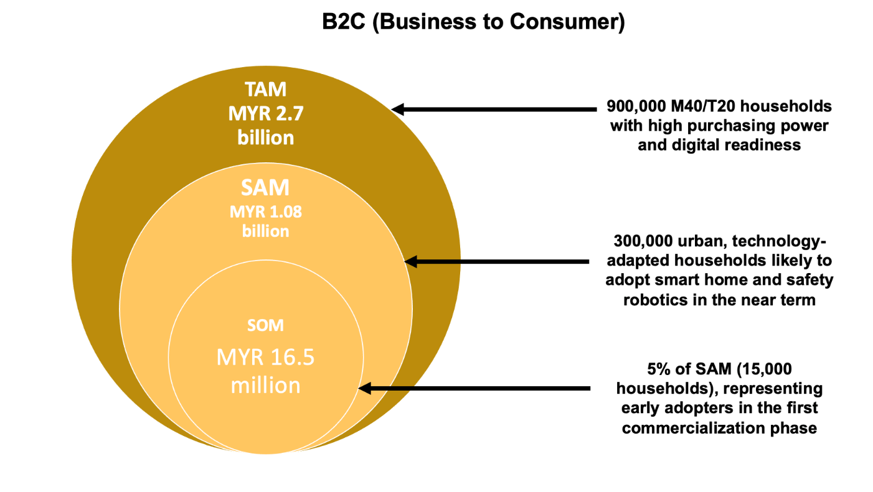
Figure 1: B2C (Business-to-Consumer) size Market Share

Business-to-Business (B2B):
-Applications:
Healthcare & hospital navigation, smart malls, retail & logistics, event management, traffic control.
-Clients:
Hospitals, logistics firms, event organizers, facility managers.
-Market Size Estimates:
TAM: MYR 1.10 billion annually (targeted industries in Malaysia)
SAM: MYR 0.55 billion (Tier 1 businesses with tech adoption)
SOM: MYR 27.5 million (5% early adopters)

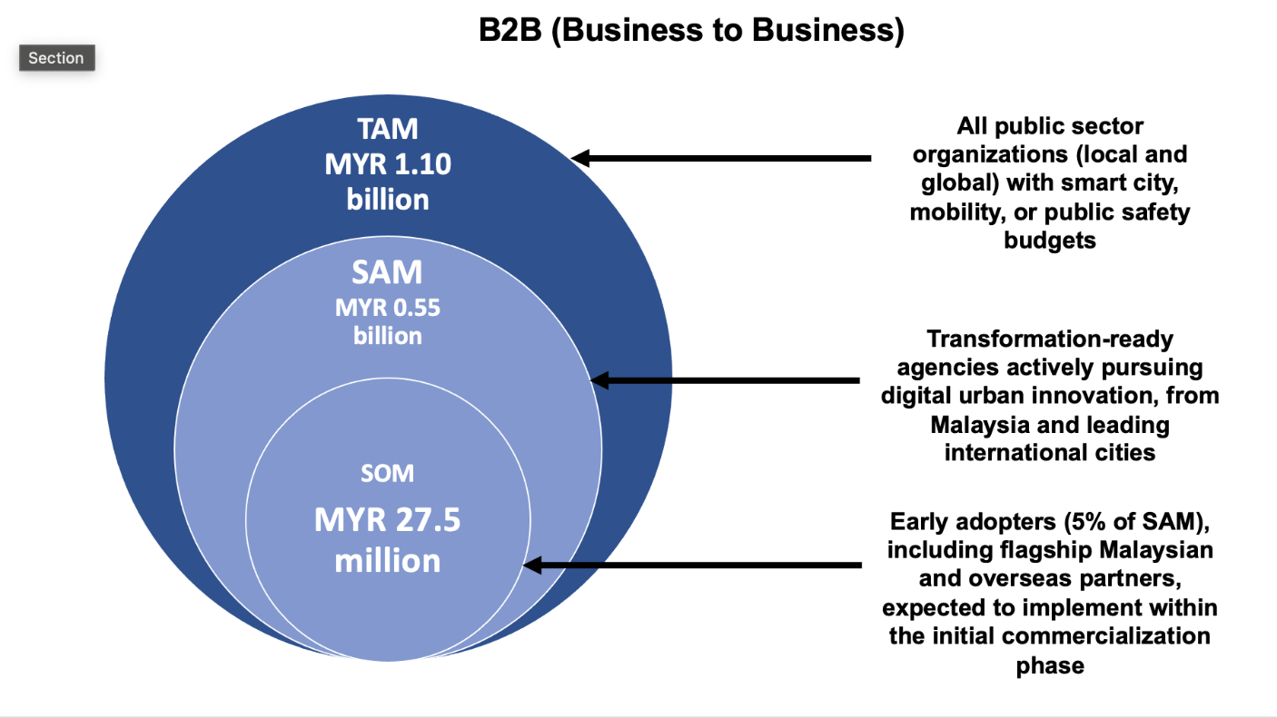
Figure 2: B2B (Business-to-Business) size Market Share

Business-to-Government (B2G):
-Applications:
Smart city development, public health, school safety, disaster response, urban governance.
-Clients:
State agencies (PLANMalaysia, NADMA, MOSTI), local governments, public safety bodies, international smart city programs.
-Market Size Estimates:
TAM: MYR 5.33 billion (domestic and international opportunities)
SAM: MYR 1.53 billion (35% of cities with transformation readiness)
SOM: MYR 75.6 million (10% early adopters, both local and overseas)

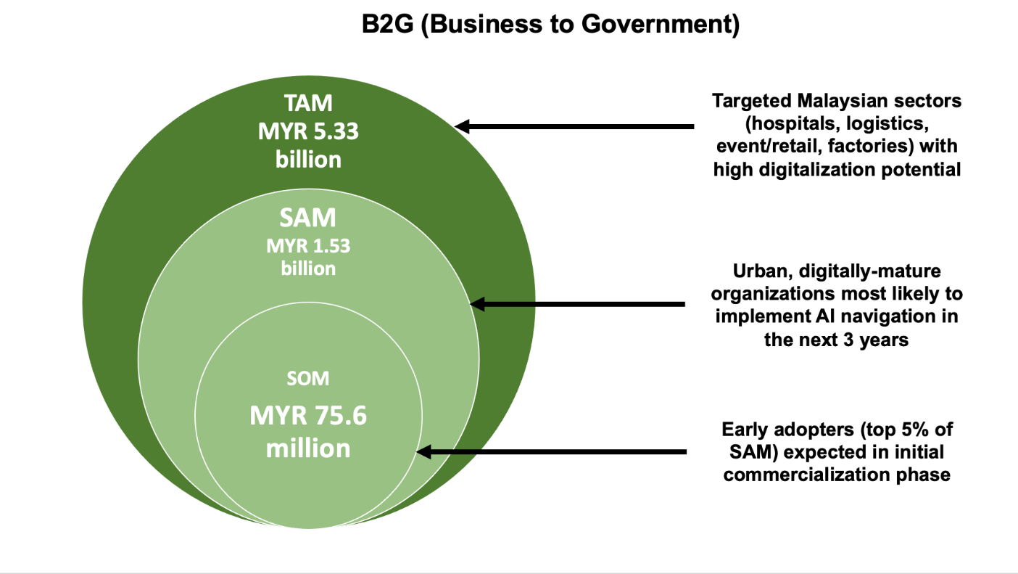
Figure 3: B2G (Business-to-Government) size Market Share

The 5% early adoption rate for B2C and B2B is grounded in Rogers’ Diffusion of Innovations theory and regional technology adoption data, reflecting Malaysia’s urban digital readiness and proven uptake of smart solutions. For B2G, a 10% rate is justified by aggressive government pilot programs and international benchmarking, driving rapid deployment among transformation-ready agencies locally and overseas.

Smart City Developments in Malaysia and Investment in AI-Driven Urban Mobility

Malaysia has been actively implementing smart city initiatives to improve urban efficiency, mobility infrastructure, and real-time pedestrian monitoring. Several cities have launched strategic smart city plans, integrating AI, IoT, and LiDAR-based pedestrian analytics into their urban development projects to optimize traffic flow and space utilization.

Pengerang, Johor (2024-2029 Smart City Strategic Plan): Pengerang has been designated as a model smart city, focusing on AI driven traffic monitoring, space optimization, and digital urban solutions to enhance connectivity and urban liveability.

Kuala Lumpur: The city has improved its ranking in the Smart City Index, moving up 16 positions, reflecting the success of AI-driven mobility solutions, pedestrian tracking, and data-driven public transport systems.

Johor Bahru (Special Economic Zone with Singapore): The region is developing a tech-driven economic hub, with investments in AI based urban planning, smart manufacturing, and pedestrian mobility analytics.

Kota Kinabalu & Kuching: These cities are implementing smart mobility and AI-assisted pedestrian flow models to enhance traffic efficiency, public safety, and emergency response strategies.

Kulim, Kedah: As an emerging industrial hub, Kulim is focusing on smart infrastructure, AI-enhanced transportation systems, and IoT-based mobility solutions.

To support these initiatives, the Malaysian government has allocated RM15.1 million to the Ministry of Housing and Local Government for smart urban infrastructure projects. Additionally, approved investments in AI-driven industries have reached RM254.7 billion in 2024, with urban mobility, AI-enhanced city planning, and smart traffic monitoring among the top-funded sectors.

These strategic investments underscore Malaysia’s commitment to becoming a leader in AI-powered smart city development.

Competitive Edge and Market Relevance
The proposed neuro-spatial navigation solution integrates real-time AI-driven pedestrian forecasting, LiDAR-based tracking, and an interactive spatial manipulation interface. This positions the research at the intersection of urgent urban needs and advanced technology, offering several unique advantages:

- Comprehensive Platform: Seamlessly combines AI, behavioral analytics, and spatial intelligence for real-world urban mobility, safety, and crowd management challenges.
- Alignment with National and Global Priorities: Supports Malaysia’s Rancangan Malaysia and Smart City initiatives, and aligns with global smart city trends and funding priorities.
- Scalable and Adaptable: Designed for deployment at micro-societal (B2C), enterprise (B2B), and governance (B2G) levels, ensuring wide applicability and strong commercial relevance.
- Strong Commercial Viability: Early engagement with government, public sector, and enterprise stakeholders increases the probability of rapid adoption and measurable impact.
- Innovation and Social Value: Promotes sustainable, harmonious, and orderly communities through adaptive mobility solutions that protect vulnerable groups, improve efficiency, and enhance public safety.
With urbanization accelerating and digital transformation high on the policy agenda, this research is well-positioned to meet the demand for intelligent urban solutions. By bridging academic innovation with commercial and public sector needs, the project offers a competitive edge and a clear pathway to market relevance, impact, and long-term sustainability.
5. Describe how the developed prototype can contribute to wealth creation, enhance quality of life and create or consolidate new industries.

The proposed AI-driven pedestrian movement forecasting and spatial manipulation prototype has the potential to revolutionize urban mobility, space utilization, and intelligent crowd management, making a significant contribution to wealth creation, quality of life enhancement, and the development of new industries. By integrating real-time LiDAR-based tracking, AI-driven forecasting models, and interactive spatial manipulation, the prototype enables dynamic space optimization, congestion control, and risk-aware pedestrian flow management. This innovative solution is particularly relevant to smart city development, public safety, urban planning, and commercial space optimization, all of which contribute to economic growth, social well-being, and enhanced public infrastructure.

1) Wealth Creation Through Smart Mobility and AI-Powered Space Optimization
The prototype will generate wealth by creating new economic opportunities in urban planning, real estate development, transportation, and AI-driven mobility solutions. Governments and businesses investing in smart city initiatives will benefit from a data-driven decision-making tool that allows for more efficient land use, optimized pedestrian movement, and improved infrastructure planning.

By reducing congestion and increasing pedestrian traffic flow efficiency, businesses such as shopping malls, event venues, and retail spaces can maximize customer engagement, increase foot traffic, and boost commercial revenue. Furthermore, the predictive AI capabilities of the system enable transport operators, security agencies, and urban planners to minimize financial losses caused by inefficiencies in space management and emergency response planning. Additionally, the introduction of AI-enhanced pedestrian analytics as a service can lead to the emergence of new AI-driven consulting firms, creating high-value jobs in data science, urban engineering, AI software development, and smart infrastructure design. The system can also be commercialized for subscription-based or enterprise solutions, allowing governments, private sector developers, and event organizers to access cutting-edge AI technology for space planning and crowd management. This opens up new revenue streams in AI-powered city planning, traffic forecasting, and smart building optimization, strengthening the market for intelligent urban
mobility solutions.

2) Enhancing Quality of Life Through Safety, Comfort, and Efficiency
Beyond economic benefits, the prototype significantly enhances quality of life by improving pedestrian mobility, public safety, and user experience in high-density environments. Traditional pedestrian management solutions often fail to provide real-time adaptability, leading to crowded, unsafe, and uncomfortable urban spaces. With the integration of real-time AI forecasting and spatial manipulation, this system ensures that pedestrian congestion is proactively managed, evacuation procedures are optimized, and movement pathways are designed for maximum comfort and accessibility.

The ability to simulate, modify, and predict pedestrian behavior in enclosed environments enables a more human-centric approach to space planning, reducing physical discomfort, stress, and risk of injuries in public transportation hubs, retail spaces, and event venues. For example, optimizing entrance and exit placements in malls or stadiums can enhance visitor convenience and safety, while adaptive congestion control in transportation terminals can reduce waiting times and improve commuter experiences.

Furthermore, improved space optimization will contribute to lower carbon emissions by minimizing pedestrian bottlenecks, reducing unnecessary energy consumption, and ensuring seamless movement efficiency.

3) Risk Reduction and Improved Safety Measures
One of the most critical contributions of this prototype is risk reduction and enhanced safety planning in public spaces, high-traffic areas, and emergency evacuation scenarios. Many disasters in high-density environments such as stampedes in stadiums, bottlenecks in train stations, and chaotic evacuations in shopping malls that actively occur due to poor crowd flow management and ineffective risk assessment. This prototype mitigates such risks by providing predictive analytics, scenario-based testing, and AI-driven spatial recommendations, allowing security personnel and city planners to implement pre-emptive measures for better crowd safety.

The real-time AI-driven forecasting model will also enhance disaster preparedness and emergency evacuation strategies, ensuring that escape routes, emergency exits, and safe zones are dynamically adjusted based on real-time movement data. By quantifying the degree of safety, comfort, and risk in various scenarios, this prototype acts as a crucial decision-making tool for government agencies, transportation hubs, and public event organizers, significantly reducing the probability of accidents, overcrowding, and pedestrian-related incidents.

4) Optimized Situations and Industry Consolidation
The ability to dynamically test and optimize spatial layouts before real-world implementation ensures that urban spaces, commercial buildings, and public infrastructure are utilized to their maximum potential. This not only benefits city planners and real estate developers but also consolidates industries involved in smart mobility, AI-driven urban analytics, and real-time pedestrian flow modeling. As AI-driven mobility solutions become an integral part of smart city infrastructure, industries involved in urban data analytics, AI-powered simulation tools, and intelligent mobility services will experience increased demand and rapid expansion.

Moreover, the prototype aligns with Malaysia’s Smart City initiatives, particularly in cities such as Pengerang, Kuala Lumpur, Johor Bahru, Kota Kinabalu, and Kulim, where significant investments are being made in intelligent mobility, AI-based urban planning, and pedestrian-friendly infrastructure. The system’s implementation in Malaysia’s smart city ecosystem will support government-backed digital transformation strategies, driving further investments in AI-enhanced pedestrian monitoring, traffic analytics, and public safety
management.

Conclusion
The developed prototype serves as a transformative tool in AI-driven pedestrian analytics and intelligent urban planning, contributing to economic growth, public safety, and industry innovation. By providing real-time pedestrian movement forecasting, interactive spatial manipulation, and AI-driven congestion control, the system offers unparalleled benefits in optimizing high-density spaces, reducing risk, and enhancing pedestrian mobility. Its integration into smart city frameworks, commercial infrastructures, and security
applications ensures its long-term impact on economic development, urban efficiency, and improved quality of life. Through risk reduction, enhanced comfort, and predictive space management, this prototype will set new benchmarks for human movement forecasting and real-time spatial optimization in urban environments, driving the next generation of AI-powered smart mobility solutions.
6. If development cost for the prototype is more than the PRGS ceiling, state how you plan to obtain the remaining fund.

The development of the prototype is fully planned within the proposed budget submitted for PRGS. However, if additional resources are required, particularly for system refinement, wider testing, or commercialization activities as the research team visioned and planned to apply for the Technology Development Fund 1 (TED1) under the Ministry of Science, Technology and Innovation (MOSTI). This ensures continuity beyond the core development phase without affecting the deliveries promised under the PRGS scope.
7. Provide the activities and potential funding sources to bring the developed prototype to commercialization.
To commercialize the AI-powered movement forecasting and spatial optimization prototype, the following activities will be undertaken in a structured three-phase strategy:
- Commercialization Vision
To launch SDSOS (Spatial Dynamics Simulation & Optimization System) and ASNA (Adaptive Spatial Navigation Algorithm) as a modular AI-powered spatial intelligence platform for confined environments, supporting safety, mobility optimization, and layout design across B2C, B2B, and B2G markets.
- Product Positioning
A plug-and-play LiDAR-based AI solution delivering:
- Real-time movement forecasting
- Risk-awareness
- Adaptive spatial optimization
- Privacy-compliant analytics (no CCTV faces)
- Scenario simulation and interactive layout manipulation

- Commercialization Pathway
Stage 1 – PRGS Phase (Prototype Validation)
- Real-environment testing with RED BEAR GLOBAL
- Collect movement datasets
- Refine RL model and UI
Stage 2 – Post-PRGS (Market Validation)
- Develop MVP
- 5–10 pilot deployments with malls, campuses, local councils
- Establish pricing and service model
Stage 3 – Commercial Readiness
- Strengthen integration, UI, and reliability
- File patent (1 expected)
- Prepare enterprise licensing
Stage 4 – Scale-Up & Spin-Off
- Establish UUM spin-off
- Bundle hardware + software solutions
- Enter Smart City ecosystem (KPKT, NADMA, PBTs)
- Regional expansion (Singapore, Indonesia, GCC events sector)

- Revenue Streams
- SaaS subscription (RM2,500–RM10,000/month)
- Hardware package (RM8,000–RM30,000 per kit)
- Consultancy (spatial audits, risk analytics)
- Enterprise licensing (RM100k–RM500k multi-year)

(b) Objective(s) of the Research

- To conduct the proof of concept by validating the existing AI navigation algorithm via prototype deployment in controlled environments, generating empirical data on real-time behavioral response and spatial adaptability to inform further refinement and scalability.
  - This objective aims to assess the algorithm’s real-time behavioral responsiveness and spatial adaptability in practical application scenarios.
- To test the integration of spatial, emotional, and crowd data inputs into the existing prototype framework.
  - The goal is to observe how well the system processes and responds to multi-source real-time data.
- To evaluate the prototype’s predictive accuracy, movement efficiency, and comfort-awareness in confined test areas.
  - Focus is on measuring user-safe navigation and avoidance performance under dynamic conditions.
- To assess the potential of the system for future scaling and smart-city integration through technical performance metrics.
  - This includes examining data flow, device interoperability, and system responsiveness across use scenarios.
(c) Methodology:
1. Description of Methodology

This research adopts a prototype-oriented development and validation approach which aligned with the objectives of the PRGS grant. The goal is to build, refine, and validate a working prototype of the SDSOS and ASNA system capable of real-time spatial tracking, adaptive path optimization, and risk-aware decision support in confined environments. The methodology focuses on iterative prototyping, real-environment testing, and user-centered performance evaluation.

Phase 1: Refining System Architecture and Technical Integration
The project will begin by consolidating key system components including LiDAR sensing, the reinforcement learning model, and the simulation interface into a unified architecture for user experience and researchers. Technical workshops with domain experts(subject matter experts will inform system alignment with operational needs and help define performance benchmarks. Technical documentation will be developed in parallel. The API expert will advise and establish a communication layer between sensors and the system dashboard, while the embedded AI engineer will implement an edge computing module (e.g., NVIDIA Jetson) to support real-time behavioural inference.

Phase 2: Conducting Controlled Environment Testing and User Evaluation
Two focus group discussions will be held with safety experts and facility managers to gather qualitative insights on user expectations of outcomes, system usability, and anticipated bottlenecks in a finite space. Early movement patterns and navigation strategies will be tested on a simulated floorplan to observe user-system interaction. Feedback from these sessions will guide refinements in the interface and the underlying simulation logic.

Phase 3: Integrating and Validating Spatial Data Fusion
The LiDAR sensor will be deployed in a real-world testbed to capture spatial movement data under varied operational scenarios. This data will be annotated and analyzed to detect movement patterns and subsequently used to train the initial AI model. Integration of this real-world data into the simulation environment will facilitate functional testing of system latency, movement accuracy, and spatial manipulation logic.

Phase 4: Tuning the AI Model and Optimizing Adaptive Feedback
The adaptive spatial navigation algorithm (ASNA) will be further trained using the collected movement data, simulating individual (agent) behaviours across multiple crowd densities with reinforcement learning. The system’s forecasting accuracy, risk prediction capabilities, and adaptability will be evaluated using metrics such as decision latency, route efficiency, and risk avoidance rate.

Phase 5: Implementing Field Pilot Tests and Stakeholder Validation
Field pilot tests will be conducted at four pilot sites, deploying the system in semi-operational conditions, such as during actual events or structured facility simulations. Structured feedback will be collected from participating stakeholders through surveys and interviews. Interface elements, alerts, and visual analytics will be refined based on observed outcomes and stakeholder input.

Phase 6: Finalizing Prototype Validation and Planning for Commercialization
The final phase will validate the complete system in an operational environment, ensuring all components function cohesively under real-world conditions. Comprehensive system specifications and deployment guidelines will be documented. The team will initiate intellectual property protection by drafting and filing a patent for the novel spatial simulation and RL movement forecasting integration. Finally, a commercialization roadmap and industry engagement plan will be developed to guide the system’s transition from prototype to market-ready solution.

Alignment of Budgeted Technologies with Research Methodology

Table 2: Technology Components and its Roles
Technology Component | Methodology  Phase | Role in Research
LiDAR Sensors | Phase 2 | Real-time spatial data capture for movement detection and modeling
Verification Cameras |  | Cross-check accuracy of LiDAR and aid in behavior analysis (e.g., expression-based emotion detection if integrated)
High-Speed Router (Gigabit Ethernet) | Phase 2–4 | Enables high-speed real-time data streaming between sensors, cloud storage, and processing units
Auxiliary System (Raspberry Pi 4 x 4) | Phase 2–3 | Embedded deployment in small-scale controlled spaces to manage sensor input and edge data preprocessing
NVIDIA DGX Spark (High-end AI processor) | Phase 3–4 | Used for large-scale AI model training (Reinforcement Learning, path prediction)
Cloud Service & Storage (AWS S3, PostgreSQL) | Phase 3–6 | Cloud database for storing spatial, behavioral, and prediction data; supports collaboration and real-time retrieval
LiDAR Data Processing (Open3D, PCL, ROS) | Phase 3 | For cleaning, visualizing, and analyzing point cloud data captured by LiDAR
AI Frameworks (TensorFlow, PyTorch) | Phase 4 | Used for developing and fine-tuning reinforcement learning models (ASNA)
Simulation Software (Unity, MATLAB, SUMO) | Phase 3–5 | Used to simulate crowd behavior, spatial manipulation scenarios, and system response to interventions
Interactive UI Tools (ReactJS, Qt, Flask) | Phase 5–6 | Build the user interface for spatial layout manipulation and decision support

System Architecture

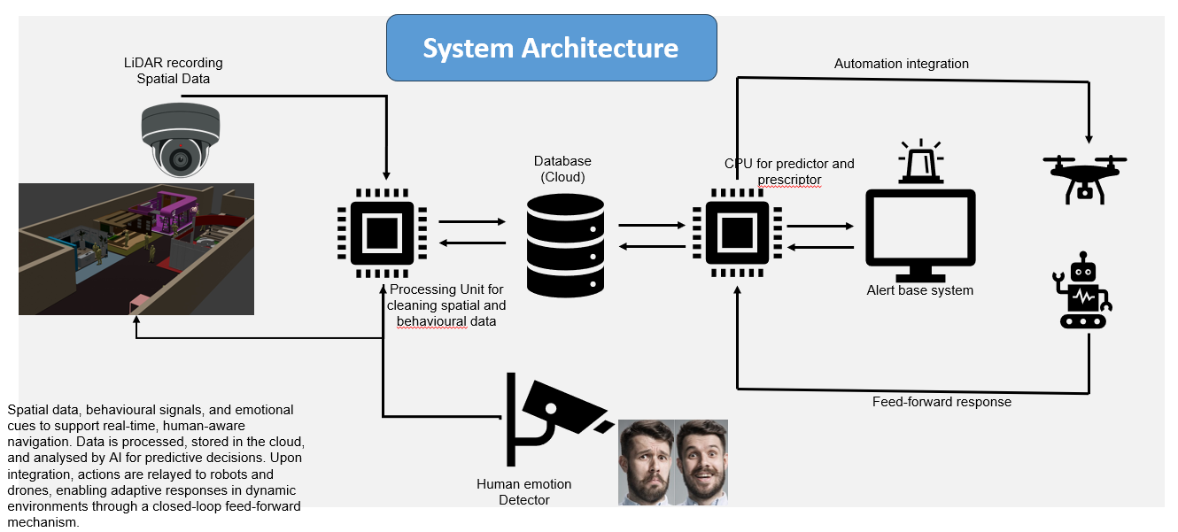

Figure 4: Human Perception based Crowd Management System Architecture

Main Component Labels (Match with Icons in Diagram):
- LiDAR Recording (Top-Left)
Captures real-time spatial data of the environment and entities in motion (e.g., people, barriers).
- 3D Spatial Mapping Interface (Bottom-Left Image)
Visualizes the scanned space and crowd dynamics for scene understanding.
- Human Emotion Detector (Bottom-Center)
Analyzes facial expressions to detect emotional states (e.g., stress, panic), enriching contextual decision-making.
- Processing Unit
Cleanses and integrates raw spatial and emotional data into structured format for further processing.
- Database (Cloud Storage)
Stores multi-source data (LiDAR, emotional cues, behavior patterns) for real-time and historical analysis.
- Predictor + Prescriptor CPU
AI engine that predicts crowd behavior and prescribes appropriate actions based on forecasted risks and environmental configurations.
- Alert Base System (with Siren Icon)
Visualizes predictions and recommended actions, notifying operators or triggering automated responses.
- Automation Integration (Top-Right: Drone + Robot)
Interfaces with robotic agents or drones to carry out physical actions (e.g., redirection, guidance) in real-world environments.
- Feed-Forward Loop (Arrow Loop Back to LiDAR and Emotion Capture)
Closed-loop system updates continuously as environment changes, enabling dynamic adaptation.

System Interface:
In finite or confined spaces, the system identifies all present entities (e.g., people, robots), maps the spatial boundary, and interprets behaviours in real-time. Using this data, it runs predictive diagnostics to forecast risks, bottlenecks, or abnormal patterns, helping prioritize attention zones and guide responsive actions.

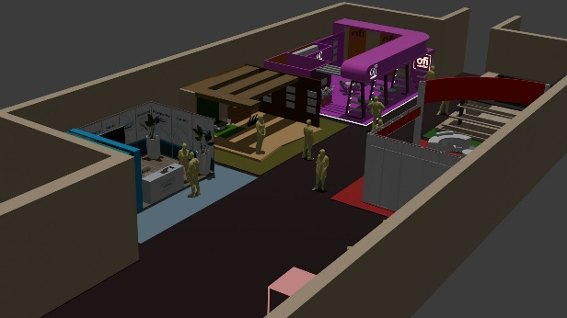. Figure 5: Real-Time Spatial Mapping Interface  Displays a confined-space layout with tracked individuals and pathways. Simulates environmental layout, including entrances, barriers, and movement channels for predictive path modeling. | 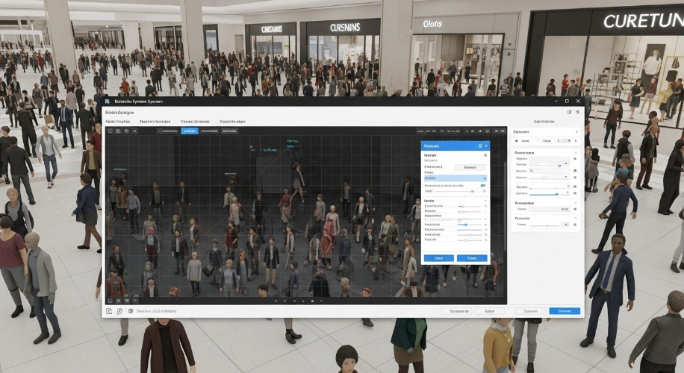  Figure 6: Entity Detection and Behavior Interpretation  System interface for recognizing human agents in a dense environment, assigning identity vectors and behavioral parameters to inform risk assessment and comfort prediction.
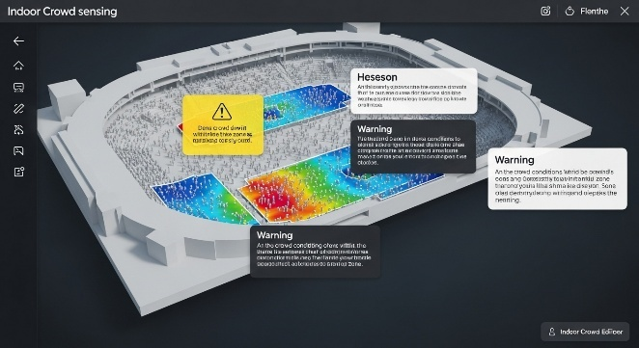  Figure 7: Crowd Heatmap & Risk Zones  AI-generated heatmap visualizing congestion levels and stress zones. Identifies real-time bottlenecks and flags high-risk regions needing immediate intervention. | 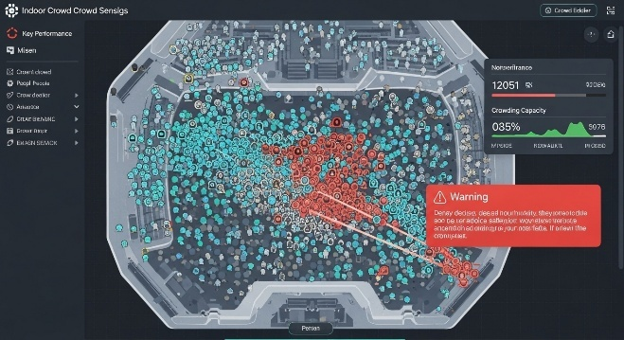  Figure 8: Predictive Crowd Behavior Simulation  Simulates movement direction, density shifts, and anomaly detection. AI forecasts high-risk movement clusters and evacuation bottlenecks using spatial behavior rules.
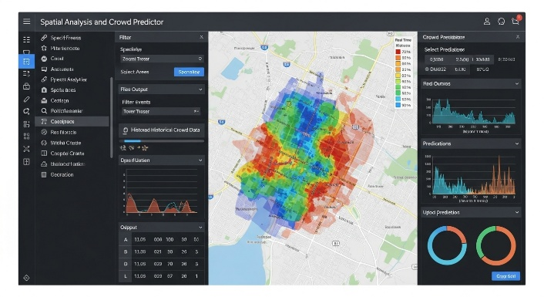
Figure 9: Spatial Risk Forecasting Dashboard
Integrates real-time geospatial data for indoor and outdoor movement prediction. Offers interactive tools for scenario simulation, risk scoring, and incident response planning.

Conclusion

This structured methodology ensures the systematic development of an AI-powered spatial navigation system that integrates real time movement forecasting, risk-reward decision-making, and interactive space optimization. By focusing on prototype validation and usability assessment, this research delivers a functional, adaptable, and intelligent system designed to improve movement efficiency and spatial decision-making within confined environments. The outcomes of this study will provide valuable contributions to industries involved in event management, facility design, and workplace optimization, ensuring a practical and impactful application of AI-driven spatial analytics.

2. Flow Chart of Research Activities
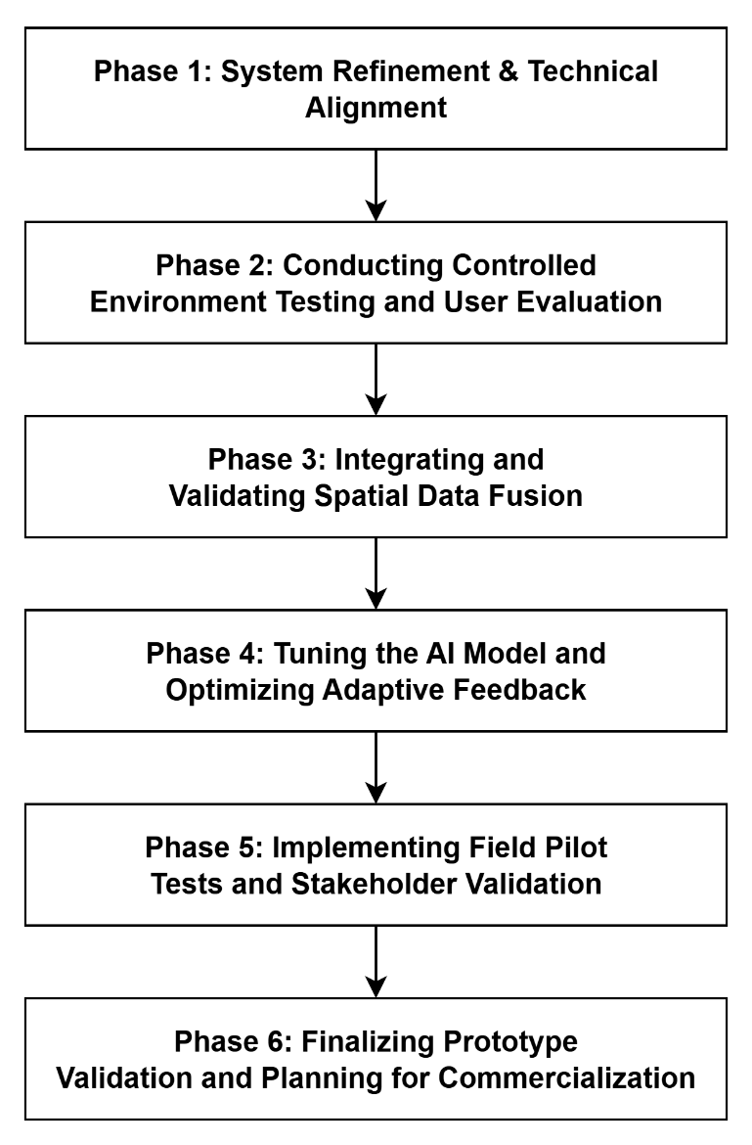
3. Research Activities
Activity | Start Date | End Date | Month
Phase 1: System Refinement & Technical Alignment | 1/12/2025 | 31/03/2026 | 4
Phase 2: Conducting Controlled Environment Testing and User Evaluation | 1/04/2026 | 30/06/2026 | 3
Phase 3: Integrating and Validating Spatial Data Fusion | 1/07/2026 | 30/11/2026 | 5
Phase 4: Tuning the AI Model and Optimizing Adaptive Feedback | 1/12/2026 | 31/03/2027 | 4
Phase 5: Implementing Field Pilot Tests and Stakeholder Validation | 1/04/2027 | 31/07/2027 | 4
Phase 6: Finalizing Prototype Validation and Planning for Commercialization | 1/08/2027 | 30/11/2027 | 4

4. Milestones
Description | Milestones | Date | Cumulative Project Completion Percentage (%)
Finalized system architecture, AI design framework, testbed setup plan | M1 | 31/03/2026 | 20
Preliminary prototype tested in simulated settings; log of technical issues and stability test | M2 | 30/06/2026 | 30
Integrated sensory data streams; report on functionality, delay, and decision logic | M3 | 30/11/2026 | 60
Optimized RL model, real-time prediction accuracy validation, latency reduction improvements | M4 | 31/03/2027 | 70
Pilot tested in real setting; stakeholder feedback collected and analyzed | M5 | 30/07/2027 | 85
Final prototype version, commercial viability report | M6 | 30/11/2027 | 100

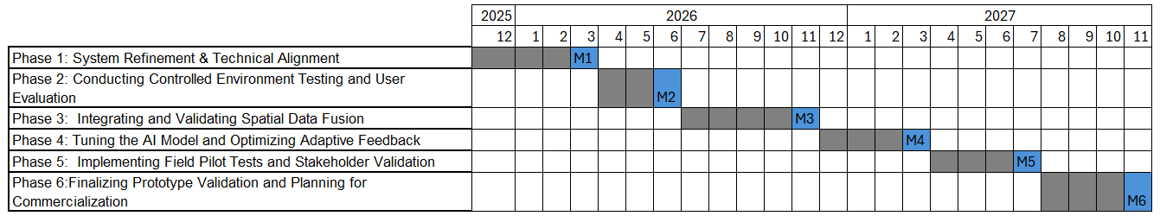

(d) Expected Results/Benefit
1. Fully Developed Prototype (Each proposal must produce at least one (1) prototype)

Name of Prototype | Description | Expected Technology Readiness Level (TRL)
Spatial Dynamics Simulation and Optimization System (SDSOS) | The Spatial Dynamics Simulation and Optimization System (SDSOS) is a real-time AI-powered spatial analysis and manipulation platform designed to optimize movement in confined spaces. It integrates LiDAR-based tracking, AI driven movement forecasting, and an interactive spatial manipulation interface to simulate and evaluate pedestrian flow dynamics. Users can modify spatial configurations, introduce occlusions, and analyze risk-reward trade-offs, enabling optimized space planning for event management, facility layout design, and high-density urban environments. | 5- Validation in relevant environment  Ready to enter technology development

2. Intellectual Property (IP) (Each proposal must produce at least one (1) IP)
Intellectual Property (IP) | Expected Number | Title of IP
Patent | 1 | Intelligent Spatial Navigation Apps for Confined Environments
Industrial Design
Geographical Indication
Copyright
Layout Design
Trade Secret
Others (excluding Trademark)

3. Research Publications (if any). Total Number of Publications Co-Authored with Industrial Collaborator
Index Body | Index Journal
 | Number of Publication | Name of Journal
WoS
SCOPUS | 1 | IAES International Journal of Artificial Intelligence (IJ-AI)
ERA
MyCITE

4. Targeted Number of Research Officer / Research Assistant (RO / RA)

Total Number of RO: NILL

Total Number of RA: 1

Remark (if any):
The RA will support key phases of the project over 18 months, focusing on data acquisition (LiDAR setup and environment testing), system integration, AI model evaluation, field testing, and documentation. The RA will play a vital role in operational tasks, stakeholder engagement, and ensuring smooth execution across technical and validation stages.
5. Impact Statement on Quintuple Helix:
Please delineate:
The research aligns with the Quintuple Helix Model by integrating academia, industry, government, society, and the environment into a holistic innovation framework. It contributes to scientific advancement, economic growth, policy development, social well-being, and environmental sustainability while positioning Malaysia as a regional leader in AI-driven intelligent decision-making and risk-aware spatial navigation

Describe expected research deliverables on Society, Academia, Government, Industry and Environment:
Society | Enhances public safety, urban mobility, and workforce AI readiness, contributing to a more inclusive and technologically advanced society.
Academia | Enhances Malaysia’s research and innovation ecosystem, positioning the country as a leader in AI-driven decision support systems.
Government | Strengthens government policy making in AI adoption, urban planning, and sustainable infrastructure development.
Industry | Accelerates technology commercialization, enhances industrial efficiency, and strengthens Malaysia’s digital transformation initiatives.
Environment | Promotes sustainable AI applications in urban infrastructure, reducing environmental impact and improving energy efficiency.

6. Application for pre-commercialization funds

To transition this research into a market-ready product, we plan to apply for the Technology Development Fund 1 (TED1) under the Ministry of Science, Technology, and Innovation (MOSTI). This funding will support the pre-commercialization phase, product refinement, and technology validation before full-scale commercialization.

E. Access to Equipment & Material(s)
Type | Description | Owner | Location | Address

G. Patent Search (describe how your research output shall produce an innovative idea or technology that has the potential to be a solution for stakeholders (community, industry, government etc.) and offers a unique proposition)
To identify if the researcher is able to coherently present a compelling argument for his/her proposal in light of the IP landscape and factors identified in the (Yes/No) Section. The answer would reflect an understanding of the applicant's research advantage and limitations and the prospect of moving the completed research beyond this stage of funding.

(Please attach Simplified Patent Search Report)

The proposed research introduces an AI-powered movement forecasting system that integrates LiDAR-based tracking, reinforcement learning algorithms, and an interactive spatial manipulation interface. This innovation addresses limitations in traditional pedestrian monitoring, which rely on static models and manual observations, lacking real-time adaptability and privacy-compliant tracking solutions. By developing SDSOS (Spatial Dynamics Simulation and Optimization System) and ASNA (Adaptive Spatial Navigation
Algorithm), this research enables dynamic space optimization, real-time congestion detection, and efficient movement forecasting for event management, facility planning, and emergency evacuation.

A patent search conducted via Lens.org using keywords spatial navigation, risk-aware decision-making, smart space planning, and reinforcement learning identified 1,517 relevant patents. The data indicates an upward trend in patent filings, especially post-2020, highlighting growing global interest in AI-driven spatial management solutions. This suggests that smart navigation and optimization technologies are emerging fields with significant commercial and research potential. The patent search revealed key potential collaborators and competitors in the field:

Potential Collaborators: Organizations such as Tran Bao, Strong Force Vcn Portfolio 2019 LLC, Automotive Tech Int, Intelligent Tech Int INC, and Lucomm Tech INC have extensive research in AI-driven navigation and spatial optimization, making them potential collaborators for further innovation.

Potential Competitors: These same entities represent active patent applicants in similar domains, emphasizing the need for unique differentiation through LiDAR-enhanced tracking, occlusion-aware movement analysis, and reinforcement learning-driven decision making.

Commercialization Feasibility and Regional Filings:
The patent search confirms that no existing patents directly prevent commercialization, ensuring freedom to operate. Additionally, no similar patents were found in Thailand, Indonesia, or Singapore, presenting a regional market entry opportunity for smart city infrastructure, industrial facility optimization, and emergency evacuation planning.

The growing patent trend confirms the relevance and high potential of AI-powered spatial optimization. The absence of blocking patents and regional filings strengthens the viability for commercialization and international expansion. By integrating LiDAR tracking, reinforcement learning, and real-time simulation, this research fills critical gaps in AI-driven spatial forecasting. The expected outcome s a scalable, privacy-compliant, and adaptive navigation optimization tool that significantly benefits industries, government agencies, and smart city initiatives. This study aligns with global trends in smart space management, offering a unique and impactful contribution to real-time movement optimization in confined environments.
H. Research Collaborator
Industrial Linkages
(Please identify any industry or end-user group involved in the project, and describe its role/contribution to the project)
 | Agency/Organisation (Please identify all agencies/organisations collaborating in the project, and describe their role/contribution to the project)
(Please attach supporting document (s) such as Letter of Intent (LoI) or any related document)

Research Collaborator: RED BEAR GLOBAL
As part of this research project, RED BEAR GLOBAL has been identified as a key collaborating organization due to its expertise in event organization and marketing campaign management. The company, registered in Selangor, Malaysia, specializes in designing and implementing large-scale events, spatial planning strategies, and audience engagement techniques, making it a valuable partner for the project.

Role and Contribution to the Project:
a. Real-world Testing and Validation
RED BEAR GLOBAL will provide real-world event environments for testing the Spatial Dynamics Simulation and Optimization System (SDSOS) and Adaptive Spatial Navigation Algorithm (ASNA). Their expertise in managing high-traffic event spaces will be instrumental in validating AI-driven movement forecasting and spatial optimization.

b. Data Collection and Scenario Implementation
The company will facilitate LiDAR-based data collection in event environments, helping refine the AI models for pedestrian flow prediction and congestion management. They will assist in implementing various spatial layouts and movement scenarios, ensuring that the system adapts to dynamic
crowd behaviors.

c. Commercialization and Industry Adoption
As a leader in event space planning, RED BEAR GLOBAL will provide insights into the practical needs of the industry, ensuring the system aligns with market expectations. The company’s marketing expertise will support the commercialization and potential deployment of the system in large-scale event
venues, commercial spaces, and public infrastructure projects.

By collaborating with RED BEAR GLOBAL, this research gains access to real-world deployment opportunities, industry validation, and a pathway for commercialization in event space optimization and smart city applications.
I. Risk Assessment (Please provide justification that may cause delays in, or prevent implementation of, the project as proposed above; estimate also the degree of risk)
Please consider an appropriate approach to working in the current conditions
(pandemic, travel ban, social distancing etc.)

Risk | Low | Medium | High | Justification
1. Technical |  |  |  | The development of SDSOS (Spatial Dynamics Simulation and Optimization System) and ASNA (Adaptive Spatial Navigation Algorithm) requires integration of LiDAR-based tracking, reinforcement learning models, and real-time spatial simulation. Challenges may arise in data processing, algorithm tuning, and multiagent interaction modeling, especially in ensuring occlusion-aware decision making. Potential issues with hardware compatibility and software optimization may lead to debugging delays. Mitigation Strategy: a. Adopt an iterative development approach, starting with a basic prototype and incremental enhancements. b. Engage with industry experts and AI specialists to troubleshoot challenges early in the process. c. Utilize open-source reinforcement learning frameworks to reduce development complexity.
2. Timing |  |  |  | The project involves real-time LiDAR data collection and prototype validation, which may require testing in controlled environments. Unforeseen logistical delays, such as facility access, hardware procurement, or licensing approvals, may impact project milestones. The requirement for real-world usability testing may be affected by operational constraints in target facilities. Mitigation Strategy: a. Establish clear timelines and contingency plans for each phase, ensuring flexibility in data collection and validation. b. Conduct simulated testing environments before transitioning to real-world scenarios. c. Utilize virtual or augmented reality-based simulations to test spatial configurations before on-site deployment.
3. Budget |  |  |  | The project relies on LiDAR sensors and computational infrastructure, which may have high initial costs. Additional funding may be required for prototype testing and iterative enhancements. Unexpected cost overruns due to AI model retraining and hardware upgrades may impact financial feasibility. Mitigation Strategy:  a. Seek additional funding opportunities through industry collaborations or innovation grants.  b. Prioritize cost-effective solutions, such as open-source AI models and cloud based computing

J. Product Marketing Plan
Product marketing plan
(briefly describe the product's application and potential, market size, target consumer and future planning in not more than 500 words)

Application/Significance:
Our AI-driven spatial navigation prototype analyzes human behavior, decision-making, and spatial interactions in confined spaces. Using AI algorithms and LiDAR-based tracking, it detects, interprets, and predicts movement choices based on perceived risk, comfort, and environmental constraints. Unlike traditional models focused solely on space utilization, this system prioritizes human perception, optimizing movement for a more efficient and harmonious environment. Beyond forecasting movement, spatial manipulation enhances controlled environments by balancing flow, comfort, and accessibility. Event managers can create stress-free crowd movement, while designers and planners can develop spaces that naturally guide people toward optimal paths. Urban and smart city developers can design layouts that adapt to human behavior, improving efficiency and well-being. By integrating AI-driven behavioral insights with spatial optimization, this technology creates intuitive, adaptive, and human-centered environments where movement feels effortless. Potential, Market Size, and Target Consumer: Malaysia is experiencing rapid
urbanization, with projections indicating that 79.8% of its population will reside in urban areas by 2025, up from 62% in 2000. This significant shift underscores the increasing need for innovative solutions in urban planning and management. The Malaysian government has demonstrated a strong commitment to smart city initiatives, allocating RM15.1 million in Budget 2025 to enhance urban living through technology and innovation. The nation's smart cities market is projected to grow by 13.27% between 2025 and 2029, reaching a market volume of approximately RM1.7 billion by 2029. This growth is further exemplified by ambitious projects such as Bandar Malaysia, which boasts an estimated gross development value of RM140 billion. Our target consumers encompass urban planners, municipal authorities, event organizers, interior designers, and traffic management agencies seeking advanced tools to improve spatial planning and management. These stakeholders are integral to the nation's urban development and are poised to
benefit from innovative solutions that address the challenges of rapid urbanization. Future Planning: Beyond civilian applications, the algorithm has strong potential in the defense sector, especially for coordinating autonomous machines in dynamic environments. By adapting this AI-driven system, drones, robots, and unmanned vehicles can move in synchronized patterns, improving navigation efficiency in high-risk or complex terrains. This capability enhances operational effectiveness for security, surveillance, and tactical deployment, where real-time spatial awareness is crucial for mission success. Another key application of the algorithm is in disaster evacuation planning and emergency response management. By integrating real-time movement forecasting with spatial manipulation, emergency teams can predict evacuation bottlenecks and ensure that high-density areas are cleared efficiently. This is particularly beneficial for large-scale events, transit hubs, and cities vulnerable to disasters such as floods or earthquakes, where rapid and coordinated movement can save lives. The system’s ability to model and manipulate space digitally provides planners with a tool to develop safer and more efficient evacuation routes. By balancing speed, safety, and accessibility, this technology makes confined spaces more adaptive to emergencies. As real-world challenges in crisis management evolve, this AI-driven approach ensures better preparedness, reduced risks, and optimized crowd movement strategies, ultimately contributing to safer and more resilient urban environments.

To address this, a Lightweight Deployment Strategy has been developed. The system is designed to be portable, modular, and deployable within minutes without requiring permanent installation or high infrastructural cost. The strategy below clarifies deployment feasibility.
LIGHTWEIGHT DEPLOYMENT STRATEGY
1. Portable Deployment Kit (Plug-and-Play)
Each setup requires only:
1× Portable LiDAR sensor
1× Edge device (NVIDIA Jetson / Raspberry Pi)
1× Tripod / wall mount
1× Laptop/tablet
Optional: verification camera
Deployment time: 10–15 minutes per location.
Everything is mobile and self-contained.

2. Dual Operating Modes
- Local Mode (offline)
Works indoors, in events, or areas with no internet
- Cloud Mode
For dashboards, reports, analytics, AI improvement

4. Deployment Workflow
- Place LiDAR on tripod
- Auto-scan environment (5 seconds)
- System calibrates
- Real-time tracking begins
- Users add/remove virtual obstacles anytime

5. Example Deployment Sites
- Indoor halls
- Mall walkways
- Train stations
- University buildings
- Stadium entrances
- Emergency evacuation drills

K. Declaration
 | All details provided in this application are accurate. KPT has the right to reject or offer without prior notice if there is any inaccurate information given.
 | This proposal is not currently considered for any other research grant(s).
 | The exact proposed work has not been funded through other research grant(s).
 | Necessary approvals from relevant bodies (i.e. Ethics Committee) are granted before research activities commence.
 | This proposed research is my original work, is not copied from my own MSc, or Ph.D. thesis or any other person's work (published or unpublished), and has not been submitted or grant application either at KPT or elsewhere.
 | In the event that I as the Project Leader depart from my affiliation with the university, the project must be taken by the Next Appointed Leader from the same university.
 | An AI-generated application was used to develop this proposal.
Name: Izwan Nizal Mohd Shaharanee |  |   Signature:
Date: 8 December 2025

Approved By:  RMC  Date: |  | Signature:

Appendix
Please list all the documents

1.Research Activities
2.BMC
3.Pattern Search
4. Research Framework
5. Agency/Organization Letter

